- Draw a figure to show storage account configured as RA-GRS
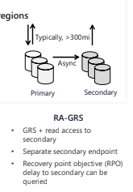

- What is required in DNS to create a custom domain for a storage account?
CNAME record is needed.

- Name the four services provided by azure on top of storage.
Container service
Table service
Queue service
File service

- What is the purpose of blob lifecycle management rules?
Transitioning of blobs to a cooler storage tier to optimize for performance and cost
Delete blobs at the end of their lifecycle
Apply rules to filtered paths in the Storage Account

- Briefly provide the purpose of azcopy and azure file sync.
AzCopy:
Command line utility
Copy blobs or files to or from your storage Account
One-direction synchronization

Azure File Sync:
Synchronizes Azure and on premises files in a bidirectional manner
Cloud tiering keeps frequently accessed files local while freeing up space.
Rapid reprovisioning of failed local server (install and resync)

- Briefly describe the usage of blob access tiers
Hot tier – Optimized for frequent access of objects in the storage account
Cool tier – Optimized for storing large amounts of data that is infrequently accessed and stored for at least 30 days
Archive – Optimized for data that can tolerate several hours of retrieval latency and will remain in the Archive tier for at least 180 days

- Why azure requires globally unique names for storage accounts?
Since the name becomes part of the URL it needs to be unique.

- Draw a figure to demonstrate storage account with GZRS configuration.
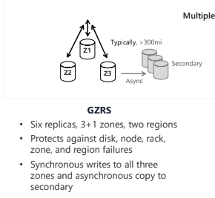

- Briefly describe the usage of azure blob and azure files. Which protocol is used by Azure files?
Container storage (blob) is optimized for storing massive amounts of unstructured data, such as text or binary data, along with file streaming videos/audios.
Azure Files sets up a highly available network file shares that can be accessed by using the standard Server Message Block(SMB) protocol.
Protocols used are SMB or NFS.

- Draw a figure to show storage account configured as RA-GZRS.
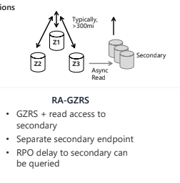

- List and briefly describe azure storage access tiers.
Hot tier – Optimized for frequent access of objects in the storage account
Cool tier – Optimized for storing large amounts of data that is infrequently accessed and stored for at least 30 days
Archive – Optimized for data that can tolerate several hours of retrieval latency and will remain in the Archive tier for at least 180 days

- What is the purpose of disk storage in azure storage services?
Disk storage provides disks for virtual machines, applications, and other services to access and use.

Other Possible Diagrams:
